

**North South University**

# Topic: Page Ranking Algorithm

Department of Electrical & Computer Engineering

**CSE482 Assignment**

Semester: Spring 2020

**Submitted to:**

**Faculty Name: Shamim Al Mamun (SAM3)**

**Submitted by:**

Name: Khadizatul Kubra

ID: 1620070042

Email: khadizatul.kubra@northsouth.edu

Date: April 29, 2020

**Answer 1**

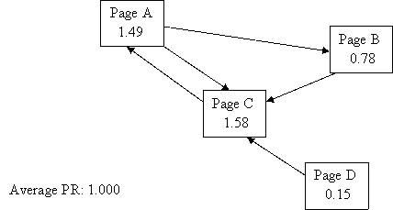

**Answer 2**

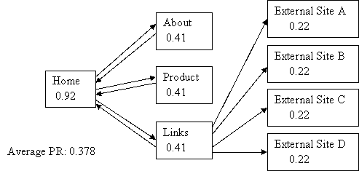

**Answer 3**

